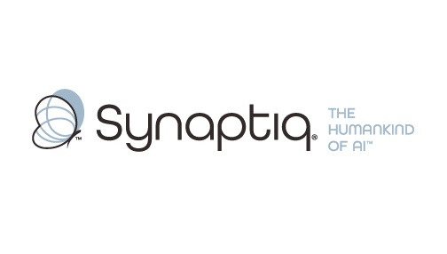
______________________________________________________________________
 | Stephen Sklarew  CEO & Co-Founder, Synaptiq  AI Strategy & Workforce Transformation | "The Humankind of AI"

Overview
Dr. Tim Oates is a distinguished AI and machine learning expert with over 25 years of experience bridging cutting-edge research with practical business transformation. As Chief Data Scientist at Synaptiq, he leads AI strategy development and delivers expert consultation on complex document processing, RAG systems, and enterprise AI architectures. His expertise in natural language processing, machine learning, and large-scale data systems has driven measurable business outcomes across industries, including optimizing document workflows in healthcare, automating eligibility determination through ML and NLP, and developing sophisticated retrieval systems. Tim's unique combination of academic rigor—with over 150 peer-reviewed publications—and hands-on delivery experience enables him to architect solutions that are both technically sound and operationally impactful for organizations scaling their AI capabilities.
Background & Expertise
Dr. Tim Oates is a seasoned AI and machine learning leader with over 25 years of experience driving innovation that transforms how organizations process, understand, and act on complex information. As Chief Data Scientist at Synaptiq, Tim specializes in architecting sophisticated document processing pipelines, RAG systems, and enterprise AI solutions that deliver measurable business value. His deep expertise spans artificial intelligence, machine learning, natural language processing, and large-scale data systems, with particular strength in translating complex technical challenges into scalable, production-ready solutions.
Tim's recent consulting work reflects his expertise in the exact challenges Thermo King faces. His projects include developing advanced document processing systems that handle diverse format types (PDFs, structured data, unstructured text), architecting RAG pipelines that optimize retrieval quality across varying use cases, and implementing evaluation frameworks that establish clear performance baselines and business value metrics. He has guided organizations through the critical 'second phase of maturity' in AI adoption, helping them move beyond initial prototypes to robust, scalable systems that handle complex document ecosystems with precision and reliability.
Prior to his current role, Tim served as Chief Scientist at CircleBack (now SalesIntel), where he pioneered AI-driven information extraction and management systems, overseeing the development of entity extraction, linking, and resolution algorithms that processed millions of documents at scale. This experience in building production systems that ingest, structure, and retrieve information from diverse sources gives him unique insight into the architectural decisions and optimization strategies required for successful RAG implementations.
As an Oros Family Professor of Computer Science at the University of Maryland, Baltimore County, Tim has authored more than 150 peer-reviewed publications on topics including natural language processing, sequence mining, and information retrieval. His research-to-practice approach ensures solutions are grounded in proven methodologies while remaining pragmatically focused on business outcomes. Tim holds a Ph.D. and M.S. in Computer Science from the University of Massachusetts, Amherst, and dual B.S. degrees in Computer Science and Electrical Engineering from NC State University.
Relevant Experience
- Advanced Document Processing Pipeline Architecture: Designed and implemented multi-format document processing systems handling PDFs, Excel, PowerPoint, and Word files with optimized extraction and structuring capabilities. Led architectural decisions for balancing generalized versus format-specific processing approaches.
- RAG System Optimization & Retrieval Quality Enhancement: Developed sophisticated retrieval-augmented generation systems with advanced evaluation frameworks and golden dataset methodologies. Specialized in optimizing retrieval quality across diverse document types and use cases.
- Enterprise AI Strategy & Maturity Assessment: Guided organizations through complex AI adoption phases, particularly the transition from prototype to production-scale systems. Expert in defining performance metrics, business value alignment, and scalable implementation strategies.
- Healthcare Document Automation & NLP: Automated eligibility determination and patient intake processes using machine learning and NLP, processing complex healthcare documents and improving operational efficiency while maintaining accuracy and compliance.
- Large-Scale Information Extraction Systems: Built production entity extraction, linking, and resolution algorithms processing millions of documents at CircleBack. Deep experience in the technical challenges of ingesting, structuring, and retrieving information from diverse document sources.
- Performance Evaluation & Business Value Measurement: Established evaluation frameworks and performance baselines for complex AI systems, with focus on translating technical metrics into actionable business insights. Expert in defining 'what good looks like' for AI implementations.

